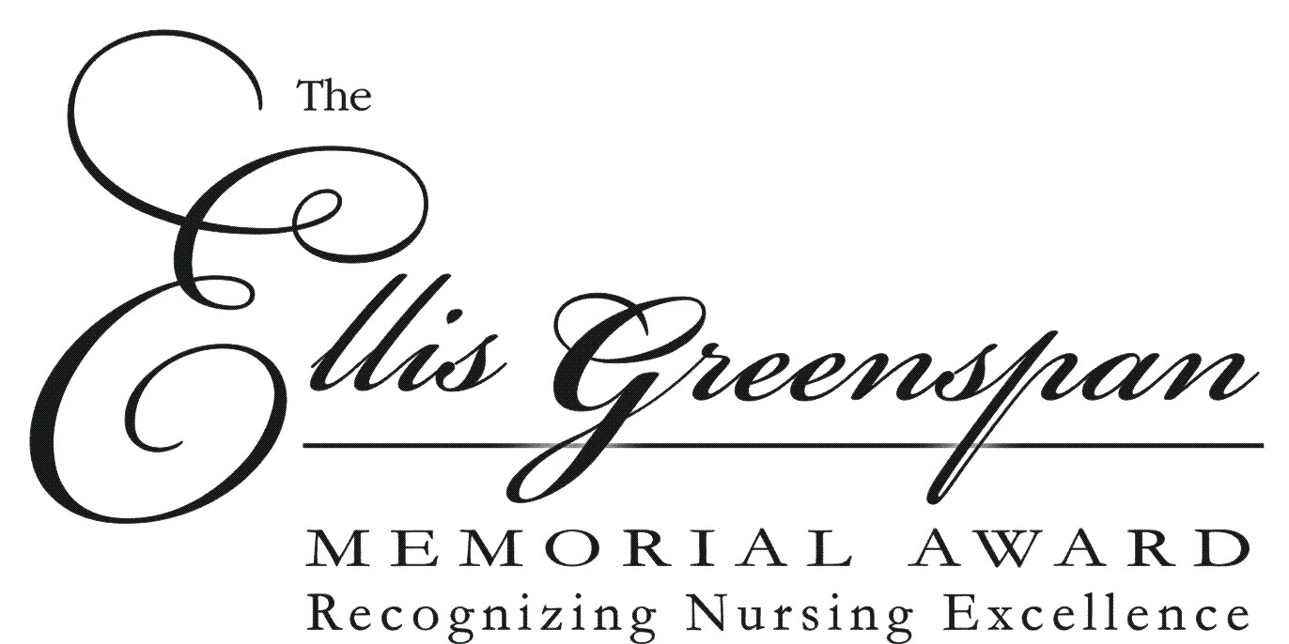

About the Award
The Greenspan family and friends established the Ellis Greenspan Memorial Award in memory of their father, Ellis Greenspan, to recognize a nurse who exemplifies excellence in the provision of patient care. The nominee should consistently demonstrate compassion, care and under-standing of the patient and his/her family during the course of illness. Nursing professionalism is to be personified in the candidate you nominate.

Nomination Procedure
- Anyone, including patients, patient family members, Grand View Hospital staff and physicians, may nominate a nurse for the award.
- Complete a nomination form in writing or on the Grand View Hospital’s web site: www.gvh.org. Be sure to demonstrate how the nominee meets the award criteria. ALL criteria questions must be answered or the nomination will not qualify for evaluation.
- Submit the on-line form or mail the completed paper form to: Grand View Health,
Pam Yerk, Nursing Administration, 700 Lawn Avenue, Sellersville, PA 18960.
- Nominees cannot win award in 2 consecutive years.
- Your nomination will be shared with the nominee.
- Deadline for receipt of nominations is Friday, May 15, 2020, by 3:00 p.m.

Basic Information: (please print)

Date: _________________________________________________________________________

Nominee’s Name: ______________________________________________________________

Unit: _________________________________________________________________________

Name of Individual Submitting the Nomination: ______________________________________

Address: ______________________________________________________________________

Phone: _______________________________________________________________________

Signature: __________________________________________ Date: _____________________

Eligibility Criteria & How the Nominee Meets the Criteria

Employment Criteria
The nominee must be an RN currently employed in good standing in a direct patient care role.

The nominee has worked at Grand View Hospital for _____ years.

The nominee’s clinical field is: _____________________________________.

Describe nurse’s patient-care role:

Personal and Professional Criteria
Please complete each of the following questions for how the nominee meets each of these criteria. Incomplete submissions will not qualify for consideration. Feel free to use back of the page if you need more room.

- Describe how this nurse partners with patients regarding their care and assists them in engaging with their plan of care.
(Minimum of 3 sentences.)

- Describe how this nurse utilizes effective communication to engage patients, patient’s families and colleagues in improving overall patient care and outcomes using compassion and nursing excellence.
(Minimum of 3 sentences.)

- Describe how this nurse gives value to healthcare and the nursing profession.
(Minimum of 3 sentences.)

- Describe how this nurse goes above and beyond to help other members on their team with compassion and respect.
(Minimum of 3 sentences.)

Supporting Documents
Please attach any documents that you believe demonstrate how the nominee meets the criteria. This could include letters and emails from patients, patient family members, physicians, colleagues and performance certificates.

